ContactManagement_Verify Contact notes _Instance44_12-Jul-2018_03-26-09_AM_SingleSignOn.png

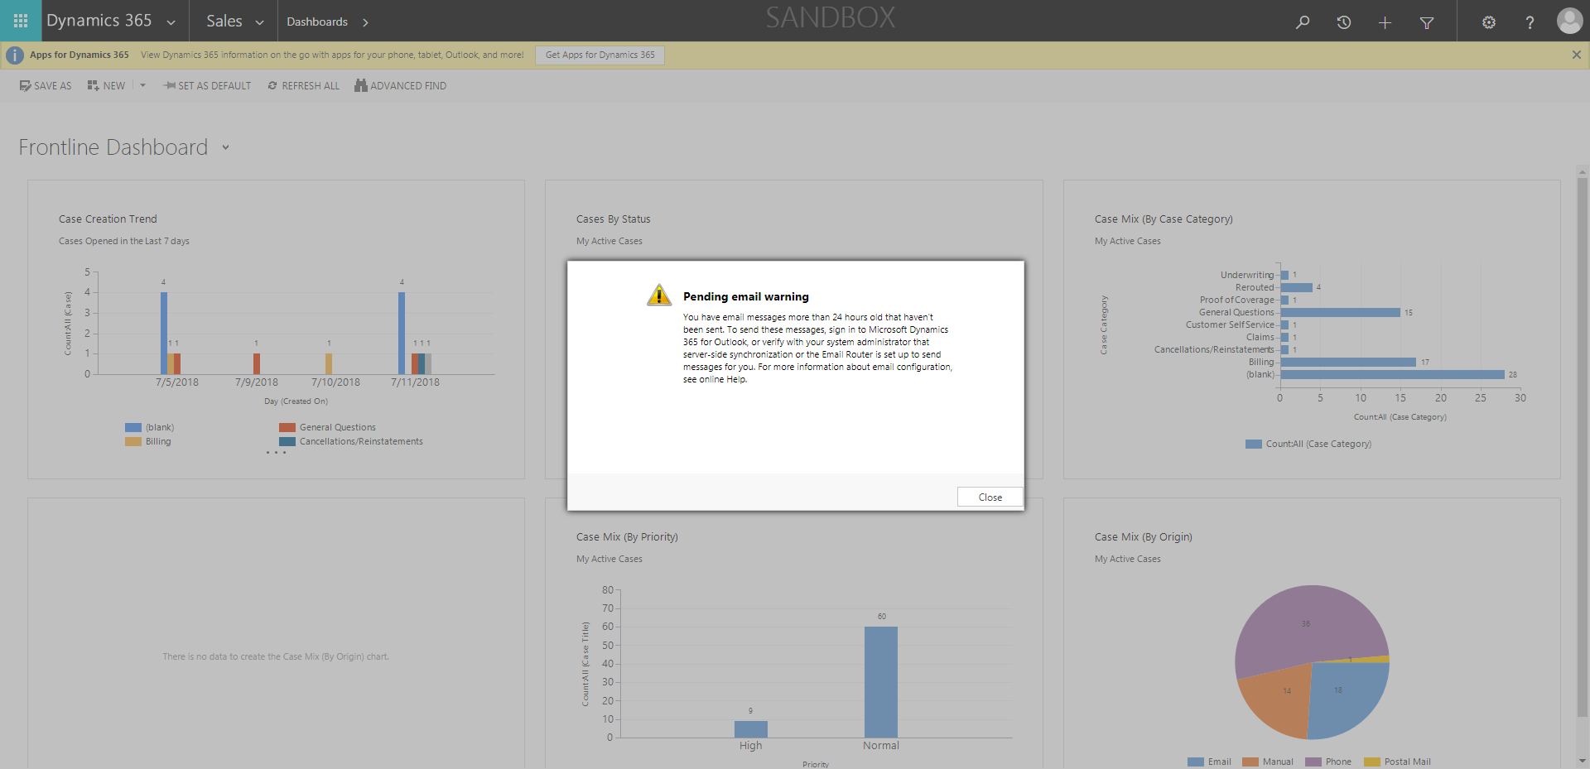

ContactManagement_Verify Contact notes _Instance44_12-Jul-2018_03-26-13_AM_SingleSignOn.png

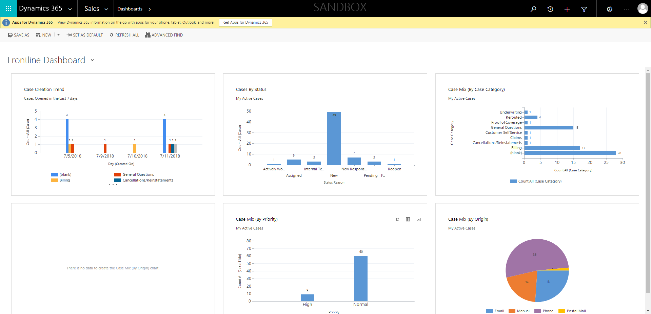

ContactManagement_Verify Contact notes _Instance44_12-Jul-2018_03-25-47_AM_EnterTextAction.png

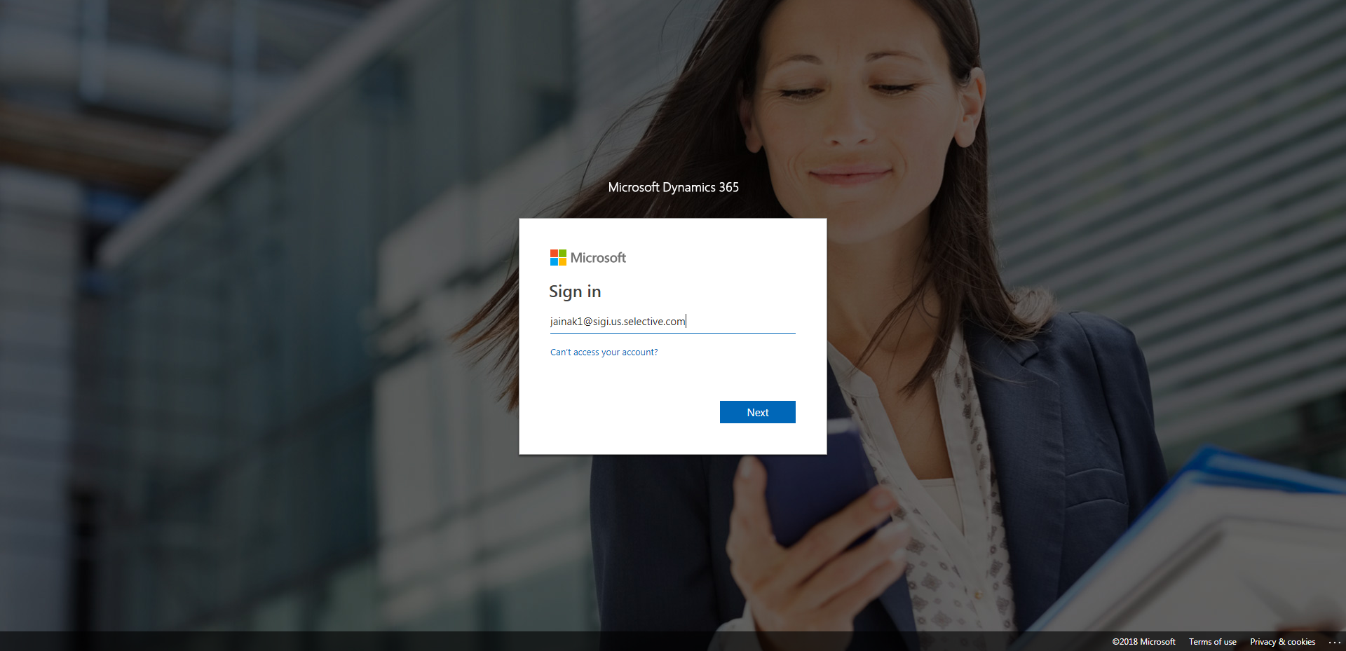

ContactManagement_Verify Contact notes _Instance44_12-Jul-2018_03-25-45_AM_MouseClickActiononStaleElement.png

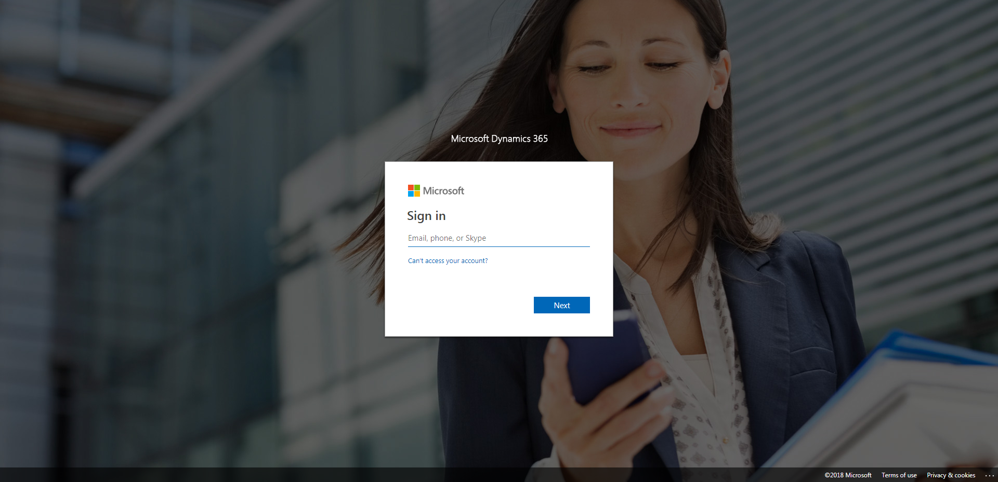

ContactManagement_Verify Contact notes _Instance44_12-Jul-2018_03-27-18_AM_Validatingcontactentitynavigation.png

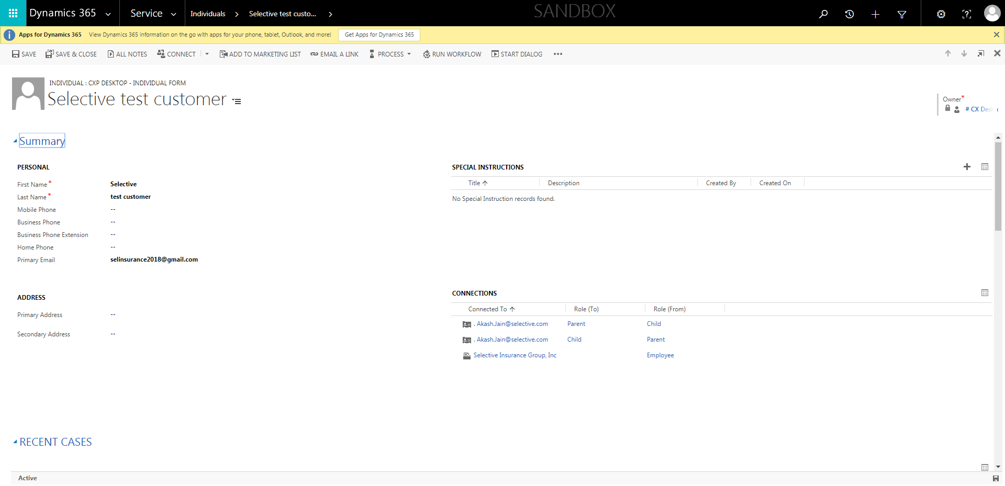

ContactManagement_Verify Contact notes _Instance44_12-Jul-2018_03-25-48_AM_MouseClickActiononStaleElement.png

